**Year 11 ATAR Chemistry**

Practical Assessment – Validation Test

Temperature & Rate of Reaction

NAME: ________________________ TEACHER: ________________________

MARKS: _____ / 16

**Answer each question in the space provided.**

1. Using collision theory, explain why the rate of a chemical reaction increases when the reactants are heated. (3 marks)

|  |
| --- |
|  |
|  |
|  |
|  |
|  |
|  |
|  |

1. Draw an energy profile diagram that shows an exothermic reaction with an activation energy value of 75 kJ and a change in enthalpy of -36 kJ. (4 marks)

|  |
| --- |
|  |

1. Identify three variables that needed to be controlled in this experiment. (3 marks)

|  |
| --- |
|  |
|  |
|  |
|  |
|  |

1. The chemical reaction that occurs between hydrochloric acid and sodium thiosulfate is shown in the following ionic equation:

**S2O32-(aq) + 2H+(aq) 🡪 S(s) + SO2(aq) + H2O(l)**

Explain the observations made during the chemical reaction. (2 marks)

|  |
| --- |
|  |
|  |
|  |
|  |

1. Explain what is occurring in the following diagram. (2 marks)

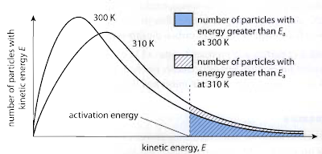

|  |
| --- |
|  |
|  |
|  |
|  |
|  |
|  |
|  |

1. What are two sources of error that are present in this experiment? (2 marks)

|  |
| --- |
|  |
|  |
|  |
|  |
|  |

**End of Validation Test**